Classified Group Rises With New Artisan Bakery and Café Concept, Rise by Classified, to Open in Central this December

Hong Kong, December 7, 2020 – Classified Group is delighted to introduce Rise by Classified, a new artisan bakery and café concept rooted in Hong Kong. Officially opening its doors on December 21, 2020, at Exchange Square Podium, Rise joins Classified and The Pawn in the group’s unique portfolio of brands.

Rise, an extension of Classified which has been a long-standing favourite in Hong Kong’s dining scene, offers a lighter alternative for casual diners with a selection of pastries, freshly baked every day using the best quality seasonal ingredients. From viennoiserie classics, like croissants and pain au chocolat, to an ever-changing array of daily specials, there is something for everyone to create a perfect start to the day.

Besides delicious baked goods, guests can also enjoy small bites to feed their appetite, such as the Benedict on Sourdough Tartine, Dutch Baby, and a new signature Rise Burger, not to mention an exhaustive list of beverages for a little pick-me-up, whether it’s a cup of coffee in the morning or a glass of wine after work.

Additionally, Rise has partnered with Hong Kong-based brands, including PÜRA VÏDA, Alive Food, and Nicole’s Kitchen, to offer a collection of locally-sourced products with guests’ wellbeing in mind. The retail section boasts a range of unique yet nutritious options to fuel the body and soul, with items like Pumpkin Spiced Granola, Blueberry Cashew Cream Cheese, Grapefruit Rose Kombucha, and Earl Grey Figs Jam.

Above all, Rise is more than just a bakery. Just like how the sun rises every morning without fail, and how kneaded dough rises into warm and luscious bread, Rise is a sunbeam of energy, full of ambition to power through the day and reach new horizons. With its inviting embrace, Rise transcends into a daily escape, away from the hustle and bustle of the city, and is the beginning to everything good in life.

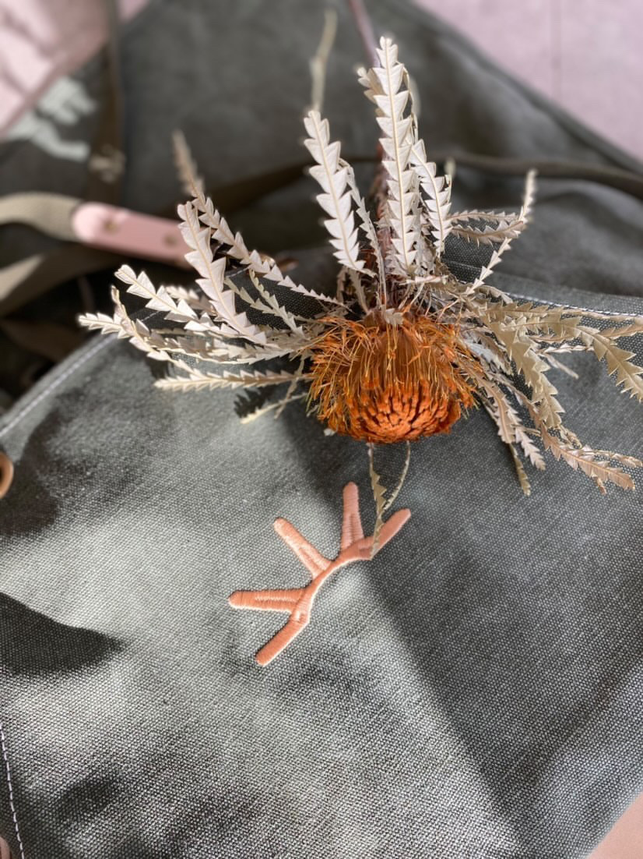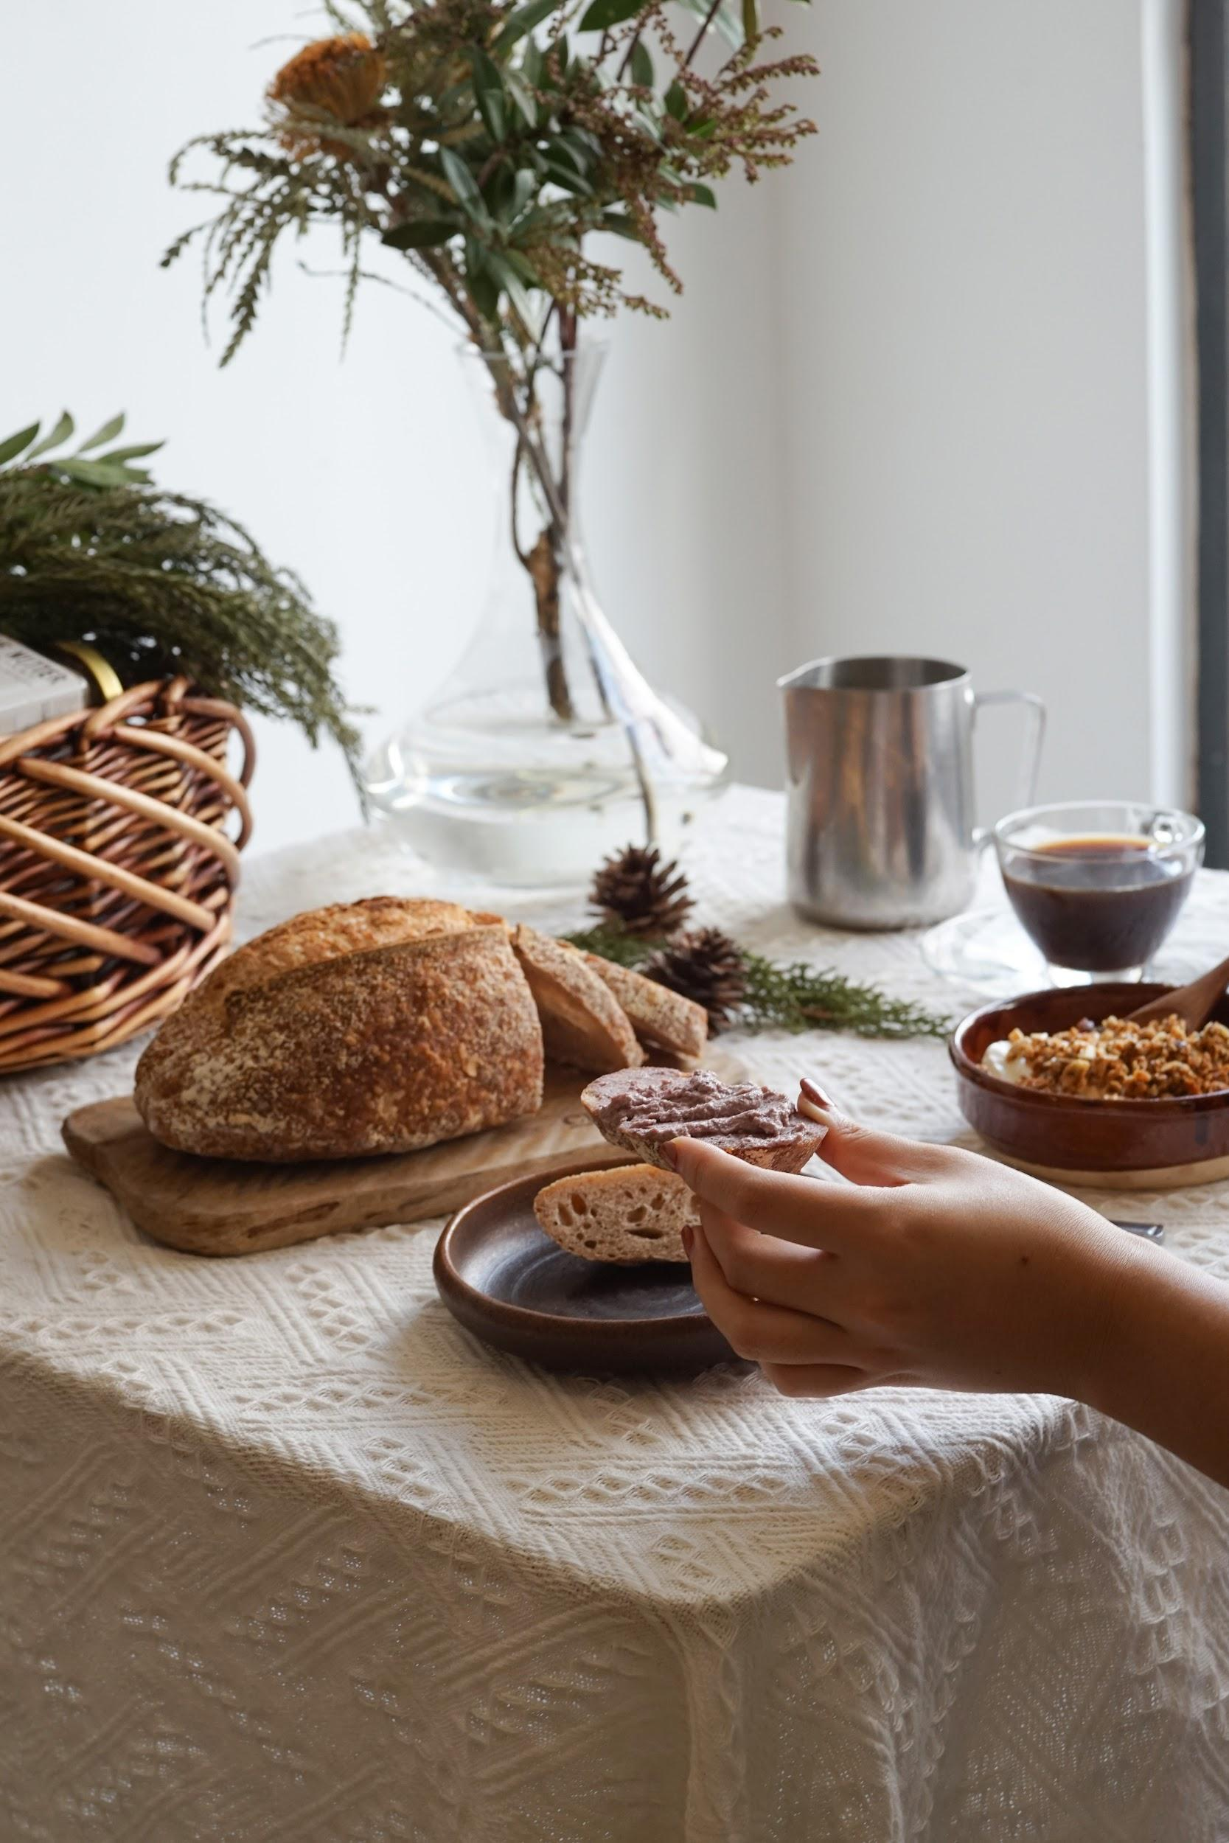
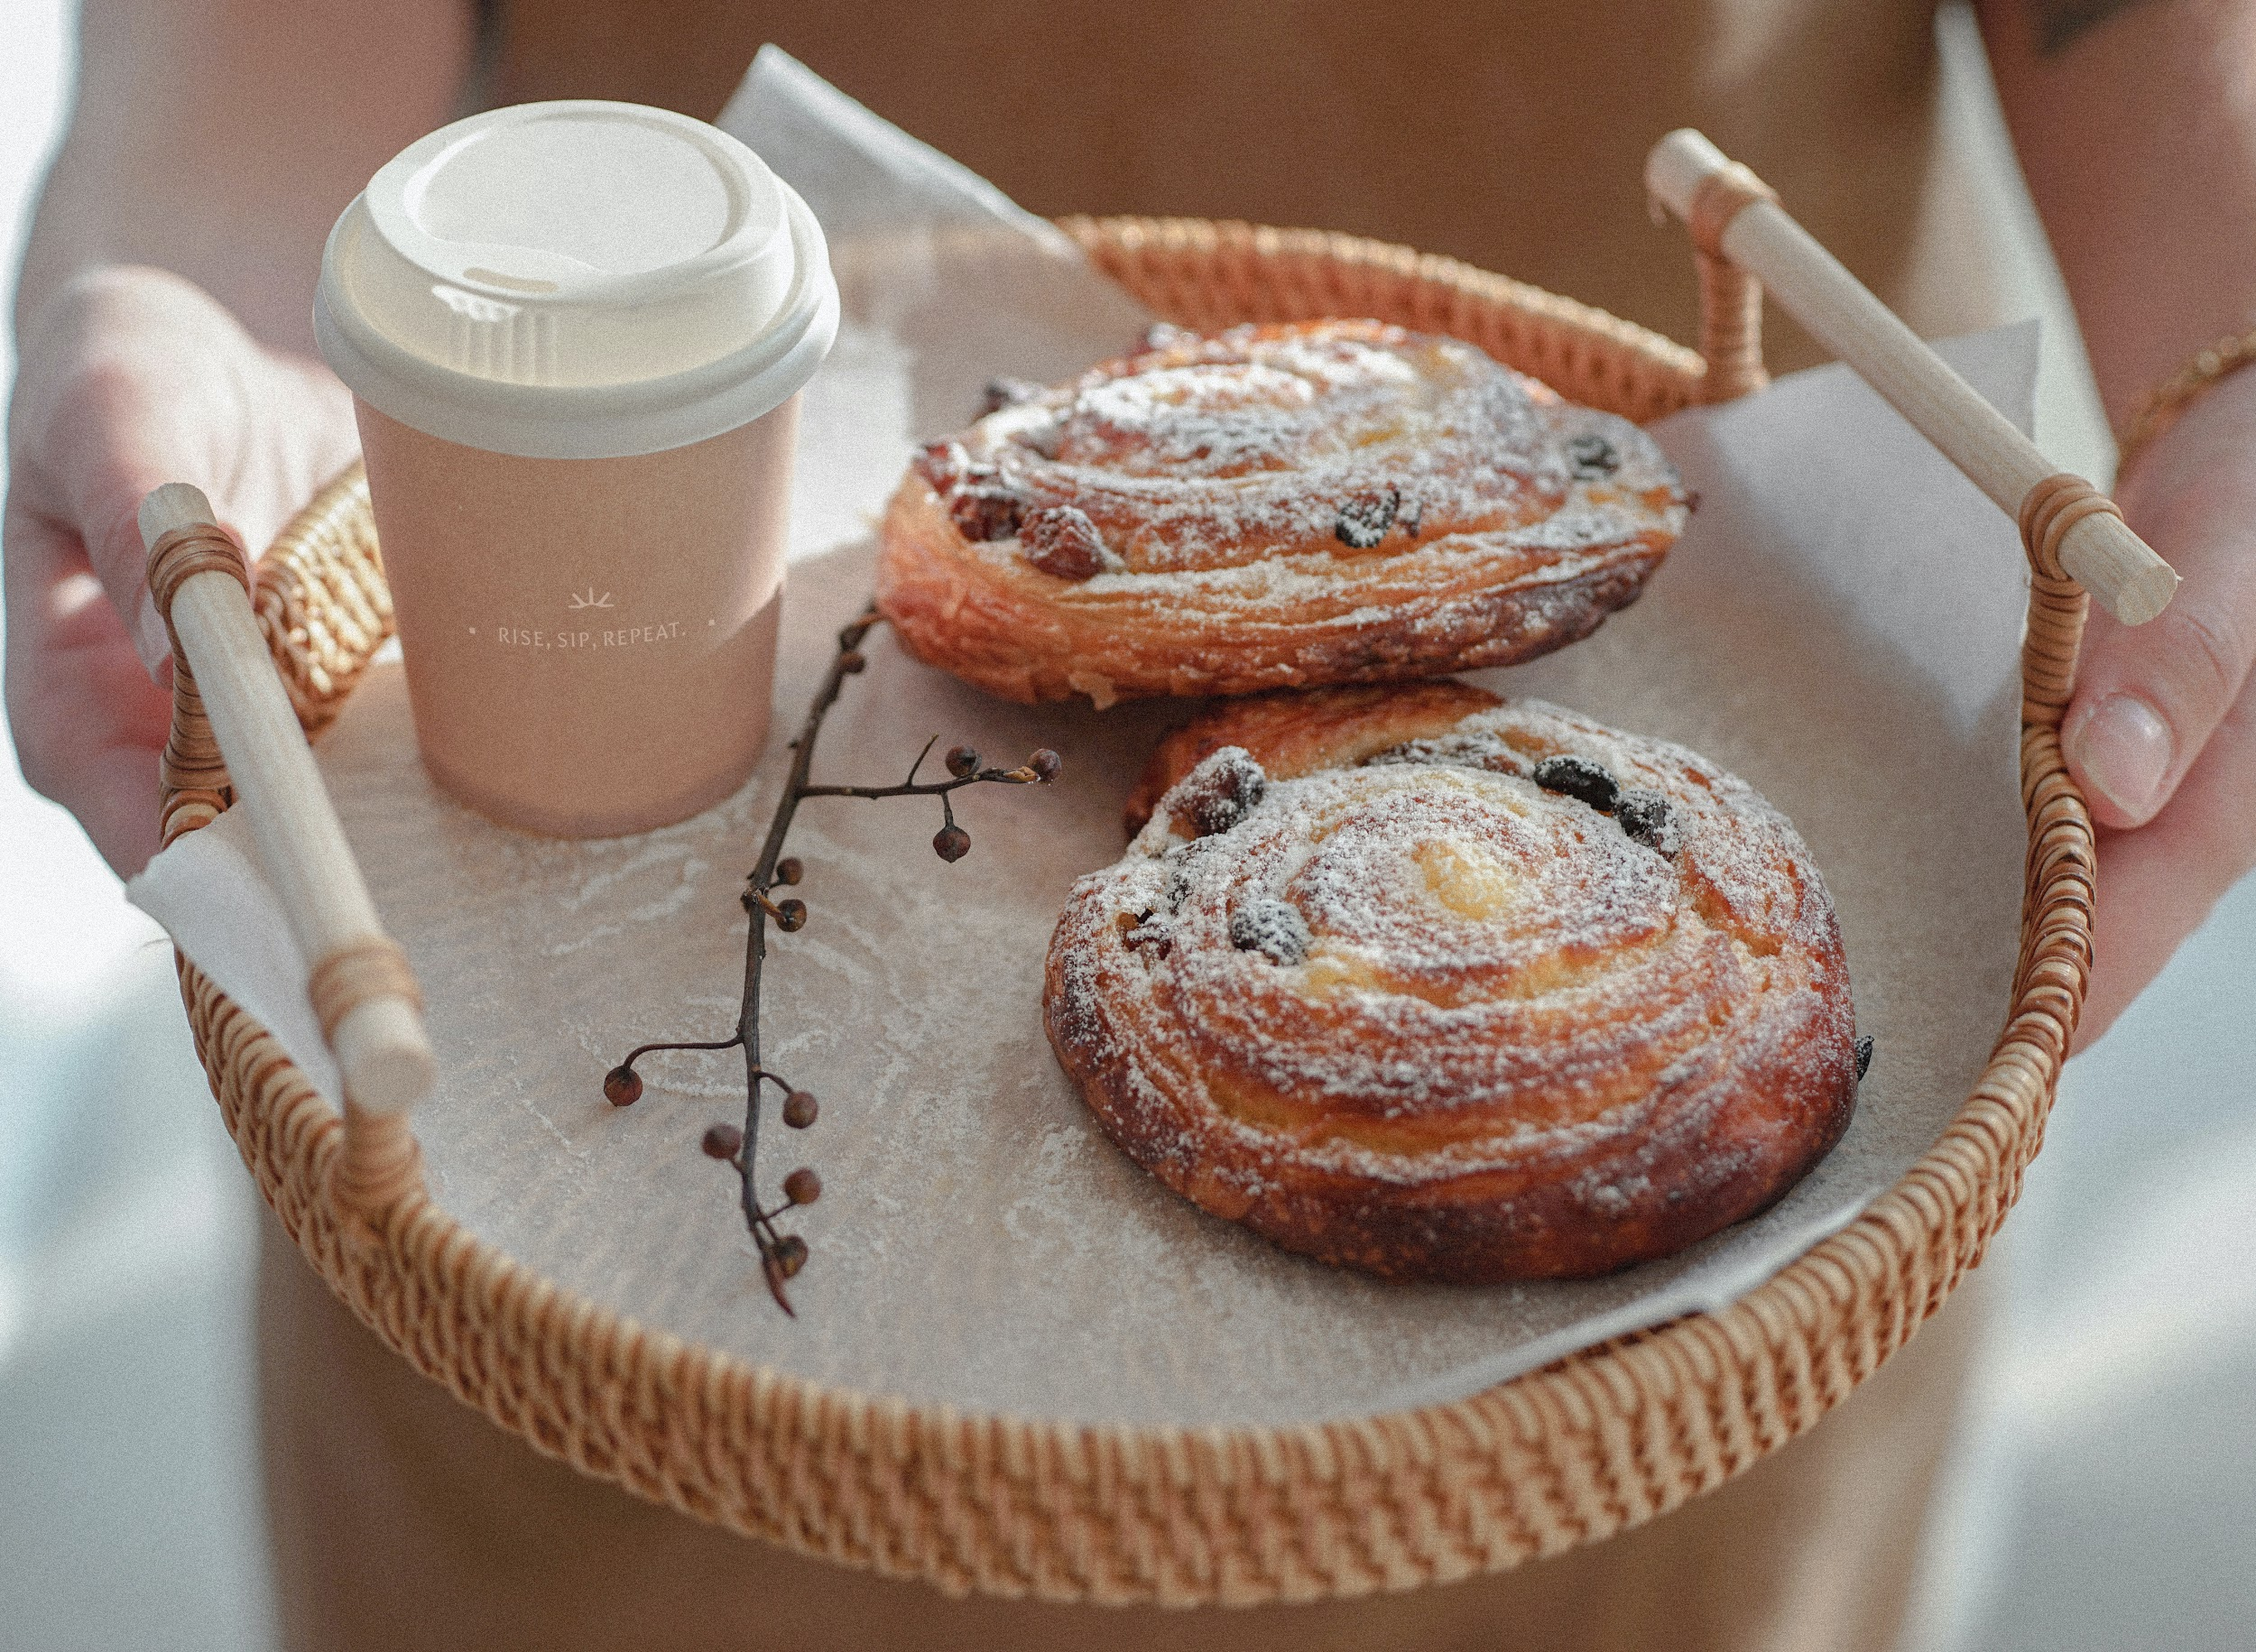

Rise is currently located at Exchange Square Podium, Shop No. 313, 3/F, 8 Connaught Pl, Central.

For more information:
Website: http://www.risebyclassified.com/
Facebook: @risebyclassified
Instagram: @risebyclassified
#risebyclassified

About Rise by Classified
Rise is a modern bakery that is rooted in Hong Kong and part of Classified Group's classic portfolio of brands. With a selection of pastries, a dine-in area for small bites, an exhaustive list of beverages, and a collection of locally sourced retail products, Rise focuses on providing a local dining experience that can be enjoyed in the restaurant or at home. Dedicated to taking care of the diners' physical and mental wellbeing, Rise provides a space to escape from the hustle and bustle of the city life.

About Classified Group
Classified Group celebrates art, culture, history and design through casual, al fresco dining experiences. Consisting of nine restaurants and cafés and profiling three unique concepts, Classified Group continues to expand and serve Hong Kong the very best of simply good food.

For media inquiries, please contact:

Claudia Cheung Joyce Ng
Head of Marketing & Communications Marketing Executive
T: +852 9868 1129 T: +852 2821 9905
claudia@classifiedgroup.com.hk joyce@classifiedgroup.com.hk

